An Unusual Purchase

My birthday month happens to coincide with annual WESTS Token Jamboree, and I always look forward to celebrating by attending the jamboree in the hopes of finding some new (to me) token from my home county of Shasta. I find that this gets harder and harder to do as I get down to just the rarer examples. I could of course start collecting from other counties, but what I enjoy most about collecting trade tokens is the personal connection between the people and places that they are associated with.
As I prepared to attend the WESTS in 2016, my parents gave me some birthday money to take with me, and my father encouraged me to "use it to buy something you wouldn't normally buy." As I was perusing the tables, and having little luck in finding any new Shasta County items, a token from the Williams Hotel Bar caught my eye. Williams is just over 100 miles from my home town of Redding, so a token from here certainly does not fit in my collection. However, Williams has been a long-time regular stopping place for my family when traveling up and down I-5; it's a great place to grab a tasty sandwich from Granzella's deli for the road, or to take a break and eat in their restaurant. I had in fact just stopped there earlier that day, so here was the personal connection to a token from a locale outside of Shasta County.

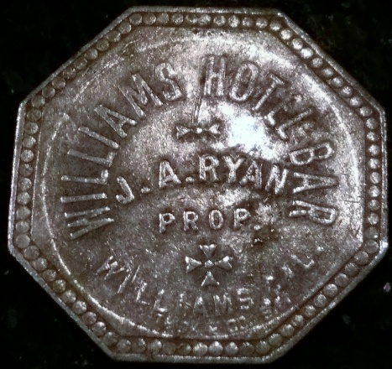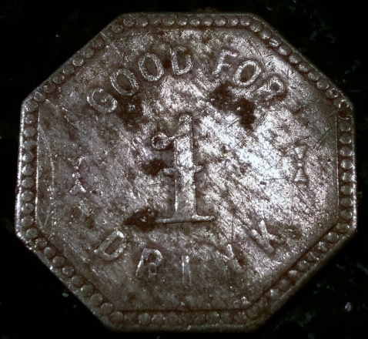

I made the purchase, and was excited to stop back in Williams on my way home to see if I could begin researching my find. It didn't take long before I was staring at a large mural of the Williams Hotel that had been completed just two years before. It is painted on the northwest side of the old Tuscan (Masonic) Lodge, built at the former site of the Williams Hotel which was destroyed in a fire in 1923.

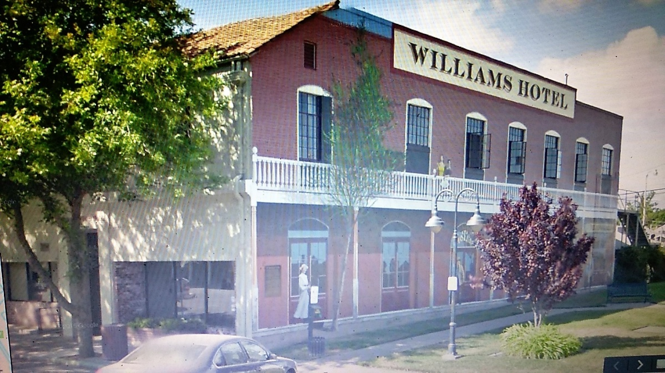

William Henry Williams

The History of Colusa and Glenn Counties (1918)* states, "Few men were more widely known or more highly honored than this California pioneer of 1850, who was the founder of the town in Colusa County that bears his name." W. H. Williams left his Illinois home on March 18, 1850, along with three companions started West in a wagon drawn by four yoke of oxen with dreams of striking it rich in the goldfields of California. It took them "just" ninety-six days before arriving at Placerville on August 1.
Williams only found seventy dollars worth of gold over a four month period, so he abandoned the work and went to Sacramento. He would work at several different jobs over the next few years, including: as a cook in a Sacramento hotel at seventy-five dollars a month; as a clerk in a shoe store at one hundred dollars a month; mowing hay with a scythe near Suisun in Solano County; as a teamster engaged in freighting "on his own account," clearing two hundred eight dollars per month; and conducting a boarding house in Sacramento for six months, "until the town was burned and drowned out." Finally he began farming on the plains near the present site of the town of Williams. He was able to buy more and more land over time, eventually giving the railroad the right of way through his property and an interest in two hundred acres. A railroad station and a post office were established there in 1874, both call Central. When the town was laid out in 1876, it was named Williams in his honor.

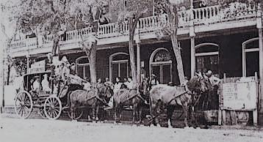

William Henry Williams erected the Williams Hotel in 1876. Over the years he was involved in several other business endeavors, including: a large warehouse building; two livery stables; a steam flouring mill; a foundry; was postmaster; built the steamer Enterprise to run from Colusa to San Francisco; and helped build the Odd Fellows Lodge where he was one of the charter members. When Williams died," the whole county mourned...in the annals of Colusa County, his name is worthy of perpetuation, for the emulation of the future generations who shall live and labor here."

John Andrew Ryan

John Andrew Ryan was born on December 1, 1863, in Springfield, Illinois, and was seven years old when he accompanied his parents to California. By age thirteen, "circumstances made it necessary for him to go to work" and he became self-supporting. Ryan made his way to Colusa County in 1882 where he worked for a leading rancher for a number of years, was appointed deputy county assessor in 1893, and later engaged in the liquor business.
Ryan took charge of the Williams Hotel on July 4, 1900, "and from the very first day of his management it bore the impress of his strong and pleasing personality…the hotel was a commodious house, well fitted and furnished, and was appreciated by all its patrons. " He sold out in 1908 in order to devote his time "looking after his varied interests," including the Jones Hot Springs property on Sulphur Creek and two vineyards. Ryan died on November 3, 1916, and was a hotel-keeper "who will long be remembered by his patrons, both tourist and resident, for the warm hospitality and the spirit of comfort and cheer always to be noted in his hostelry, and so suggestive of the old-fashioned days."

* All quotes are from this source.

Chet Sunde, Psy.D., is a Clinical Psychologist living in Redding, California.

